| **Test Name** | | | User Can Access Sensors Read From File Consistently | | | |
| --- | --- | --- | --- | --- | --- | --- |
| **Use Case Tested:** | | | View All Sensors | | | |
| **Test Description:** | | | The “Sensor” menu option is clicked and the window with a list of all sensors is displayed. The Test is then repeated a second time to check for consistency. | | | |
| **Pre-conditions** | | | Must Not Be On The All Sensors Screen | | | |
| **Post-conditions** | | | The currently displayed window should be that of all sensors window | | | |
| **Notes:** | | **Unsure how else to demonstrate a button click other than through screenshots.** | | | | |
| **Result (Pass/Fail/Warning/Incomplete)** | | **Pass** | | | | |
|  | **TEST STEP** | | | **EXPECTED TEST RESULTS** | P | F |
|  | Run The Application In the development environment | | | Application Opens | X |  |
|  | Click On Sensors On Menu | | | All Sensors Window Is Displayed | X |  |
|  | Close Application With Either “Exit” Menu Option Or Red “X” | | | Application Closes | X |  |
|  | Repeat Above Steps | | | Same As Above | X |  |
|  |  | | |  |  |  |

**Test Output Screenshots**

Cycle 1

Start

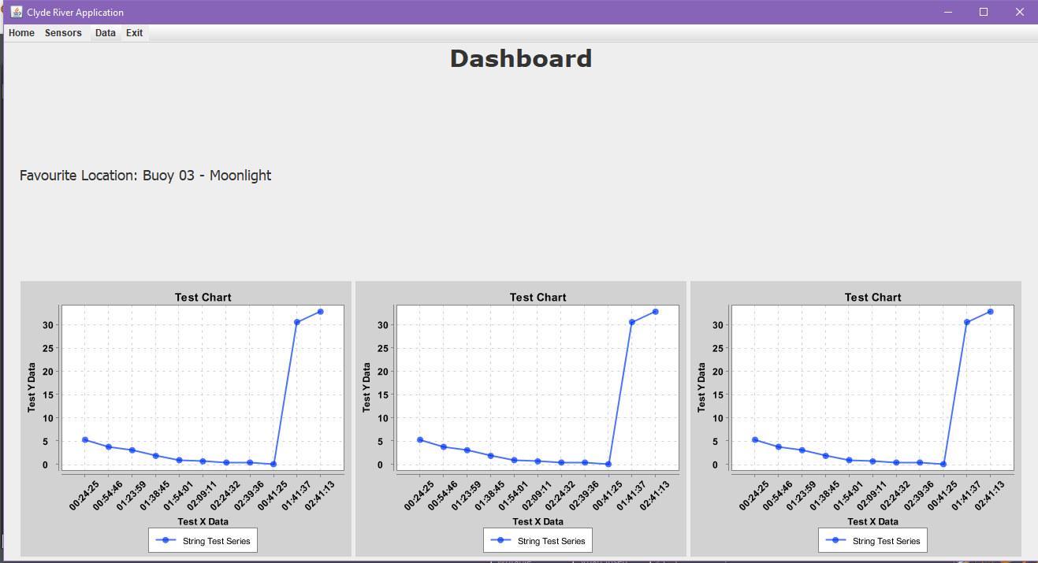

Result

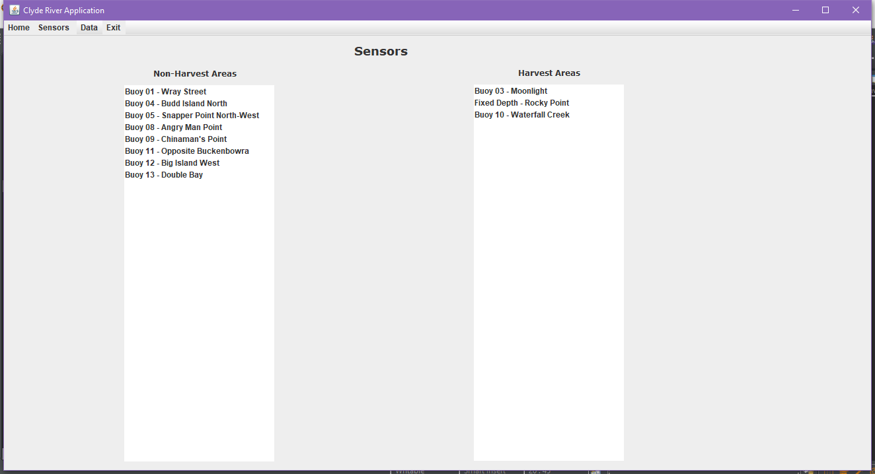

Cycle 2

Start



Result



Cycle 1

File I/O

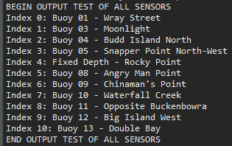

Cycle 2

File I/O

